**Sandhya Khandagale’s Design Document**

1. **Goals and Mission**
2. **Mission Statement:** To create Christian database webpage for Christians searching for various kinds of kinds of Christian based resources all throughout the internet.
3. **Goals:** A fully functioning website that includes all kind of resources for all kinds of Christians to reach in ease.
4. **User Experience**
5. **Audience Definition:** School-aged children to even seniors of older ages with internet access.
6. **Scenarios:** A 12 year old child named Josh attending Spencerville Adventist Academy, a 22 year old volunteer missionary named Sarah, and Mike, a youth pastor, used the website. (For the full detailed scenarios, see **Appendix A**)
7. **Competitive Analysis:** There are many different types of Christian Resource webpages, some are fully functional and have some great features, such as many categories and links to choose from and as well as good purpose statements. Yet, they lack in no search engine or either low functioning search engines. The webpage designs weren’t very appealing and some were basic. Also, even though the content was great, the content was not organized well and was not arranged in a good fashion. (See chart in **Appendix B**)
8. **Site Content**
9. **Content Group and Labeling** (See chart in **Appendix C**)
10. **Functional Requirements:** The most important details needed in the website are link function, an online submit links form, a search engine bar, and an interesting web design. Link function is most important detail on the website because the links are the main purpose of the website. A search engine bar is important because that is the way to find all the content on the webpage. An online submit links form is an important way of gathering other suggestions, resources, and input from users. Another big part would be web design because if the website isn’t appealing, no one will want to use the website.
11. **Content Inventory** (See Chart in **Appendix D**)
12. **Site Structure**
13. **Metaphors:** I picked an organizational metaphor of a library based theme. Because the topic is about various online Christian resources, a library format would be the best fit. The driving rational behind this website is to help people find resources all in one place, same way with a library. The library theme would work best for this site’s structure.
14. **Site Structure Listing** (See chart in **Appendix E**)
15. **Global and Local Navigation Systems**
16. **Global Navigation:** The homepage including the menu, search engine bar, and the description of the website are the main basic Global navigation systems.
17. **Local Navigation:** The submit links application, the contact us option, and all the rest of the links of resources are considered local navigation.
18. **Visual Design**
19. **Layout Grids** (See chart in **Appendix F**)
20. **Mood Boards** (See chart in **Appendix G**)
21. **Page Mock-Up**

**Low Fidelity Mock-Up** (See chart in **Appendix H**)

**High Fidelity Mock-Up** (See chart in **Appendix I**)

**Appendix A**

1. A 12 year old child named Josh attends Spencerville Adventist Academy and was assigned to do a project on the progress of Christian mission work in other countries. He needed to find some good information on it so of course he turned to the internet. He knew there must be many articles based on mission work in various countries but he wanted to find the best ones. He thought to himself that he should look for various resources based on it. So first he searched on Google for a “Christian Resource List” and searching through the results, he came across our website. He clicked on the link and opened up to a great homepage, explaining the description of the website as well as appealing graphics. He also saw a search engine bar and typed “Christian Mission Work in Other Countries” in it. Almost immediately, the webpage redirected him to a screen on regarding his search. It was filled with various links that he could search through to find the ones he wanted. He looked through the list and saw a link for ADRA’s mission work that interested him and he clicked on it. As soon as he did, he was redirected to the ADRA page and he got all the information he needed. When he went to school the next day, he got an A on his report and recommended the website to his all his friends.
2. 22 year old volunteer missionary named Sarah was doing mission work with her other volunteer missionary friends in Pakistan. She and other volunteers had been distributing various Christian literature there for all the people who weren’t Christians yet. She thought this literature was interesting but she also knew this was an age of technology and she thought it would be more appealing to the other Christians there if she could find a website they could visit easily that had all the information on Christians morals and values that they would ever need to know. So that’s what she did, she searched for “Christian Resource Database”. Finding our website, she clicked on it and was intrigued by our homepage. It described the purpose of the website in a clear way. The search engine was right there and she could easily search up anything she wanted. She typed in “Sabbath” just to test out the website and she was very pleased. It took her straight to a list of Christian-approved Sabbath links and clicking on one, she was taken to a great article about the Sabbath. She was very satisfied with the website and shared it with all the people.
3. Mike, a youth pastor, had been using this website for a very long time and was interested by the results and ease of the website every time he used it. One day, he was to look up resources for his sermon topic when he noticed a submit resource button on the webpage. He was puzzled by what it was so he clicked on. It was a “Submit Resource Form”. He read the description on top and it was basically a part of the site where if he had stumbled upon a link before that was helpful to him, he could submit it to share with others. Once before, he had found an interesting webpage about the Ten Commandments so he thought he would submit it. Filling out the short application on the website, he was proud that he could put his input on this very useful site. After submitting it, he looked for whatever topics he needed and was a pro at using this website.

**Appendix B**

|  |  |  |
| --- | --- | --- |
| **Features** | **www.christian-resources.net** | **http://www.missionresources.com/** |
| Web Design | Could be more appealing. | Not captivating enough. |
| Easy Access | Had a menu with each category. | Only listed them alphabetically but not by content. |
| Availability of Resources | Not many resources were listed. | Listed many resources. |
| Link Function | The links went straight to articles on the website. | Most of the links went to functioning websites but some links were expired. |
| Web Description | The description is long and gets to the point only reading for a while. | The description is very basic but makes sense. |
| Purpose for Website | Purpose is to list Christian resources for easy access. | The purpose is to list resources for Christians all in one place and is clearly stated. |
| Search Engine | No search engine. | Has a custom Google search engine but is not able to search directly on the site, on through Google. |

**Appendix C**

|  |  |  |
| --- | --- | --- |
| DESIGN | RESOURCE | SEARCH |
| Webpage Design | Links | Menu |
| Description | Submit Links | Search Engine Bar |
| Contact Us |  |  |

**Appendix D**

**CONTENT FUNCTIONALITY**

Webpage Design (!)

Description

Contact Us

Links/Resources (!)

Submit Links Forms

Menu (!)

Search Engine Bar (!)

Copyright Agreements

**FUNCTIONAL REQUIREMENTS**

Webpage Functionality, Appealing Graphics

Mission Statement, Goals

Contact Information

Link Functionality and Description

Submit Links Online Form

Menu Categories

Search Engine Bar Function

Copyright Agreement Page

(!) - important

**Appendix E**

Search Engine Bar

Menu

Description

Resources

(Links)

Submit Links

Contact Us

**Appendix F**

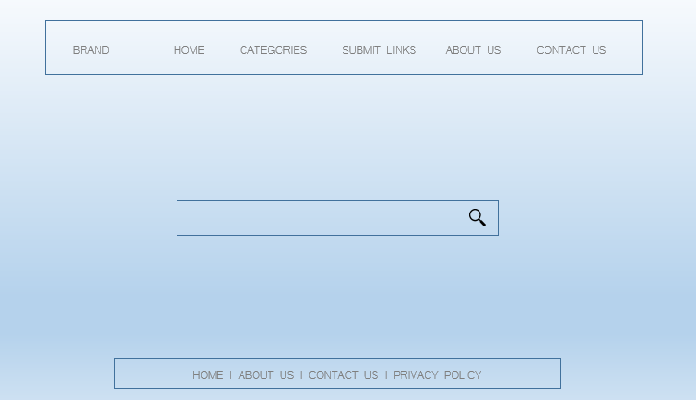

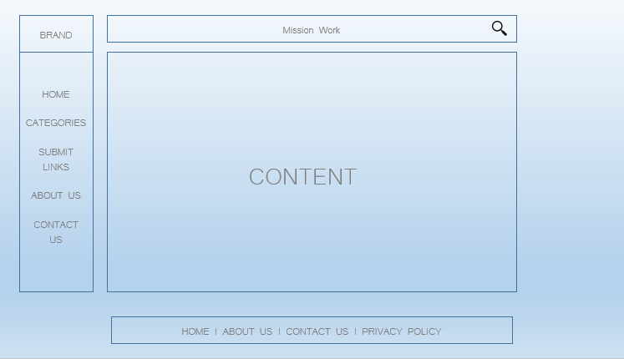

**Appendix G**



**Appendix H**





**Appendix I**

